TrendPulse GoldenGoose
E4 · User Guide
Part 2 — The Deep Dive
Every input that matters — the important knobs, the minor ones that still move the needle, and the full AI sidecar setup for Windows and Mac.

Open by design
GoldenGoose is fully open source, so nothing here is hidden. This guide walks the actual input groups as they appear in MetaTrader — the same panels you see in the EA’s settings — and explains what each one does and when to touch it.

Part 1 (setup & run): https://drive.google.com/drive/folders/1hs271IgDDpWyc_rVt1Ud6rA2V0ttW2GL
Home / landing page: https://trendpulselabs.github.io/

1 · How the inputs are organised
When you drop GoldenGoose on a chart, the Inputs tab groups its settings into logical blocks. You don’t need to touch most of them — the defaults are the verified configuration. This guide flags which inputs are high-impact (change the behaviour meaningfully) and which are minor (safe to leave, but useful to understand).
Golden rule of tuning
Change one input at a time, then re-run the tester over the same window and compare. If you change five things at once and the result shifts, you’ve learned nothing about which one did it. This is how the whole system was built, and it’s how you should tune it.

2 · Symbol & account
The first thing most people need: telling the EA which gold symbol to trade. GoldenGoose can auto-detect, or you can pin it explicitly.
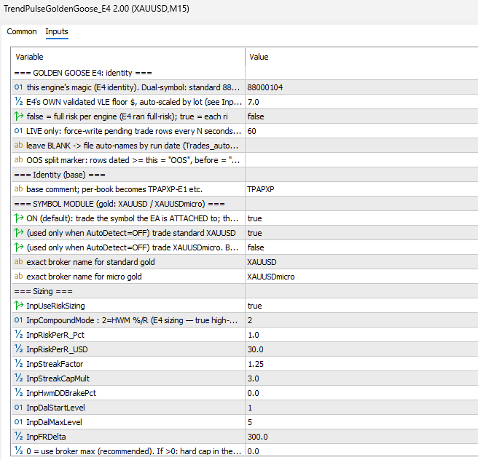
The symbol / account group as it appears in MetaTrader.
Input | What it does
InpAutoDetectSymbol | High-impact. ON = the EA trades whatever gold symbol the chart is (XAUUSD or XAUUSDmicro). This is the simplest setup: attach to the right chart, done.
InpTradeXAUUSD | Force-enable standard XAUUSD trading. Use when you want to pin the symbol rather than rely on auto-detect.
InpTradeXAUUSDmicro | Force-enable XAUUSDmicro trading. Under $500 → this is the one you want.

Switching between XAUUSD and XAUUSDmicro
The cleanest way: leave InpAutoDetectSymbol = true and simply attach the EA to the chart of the symbol you want. To run both at once (a standard and a micro account, say), run two instances — one on each chart. The magic numbers differ per symbol (88000104 standard, 88000114 micro), so they never collide.

3 · Risk & compounding
This is the group people most want to tune — and the one to treat with the most respect. It controls how much you risk per trade and how aggressively the account compounds.
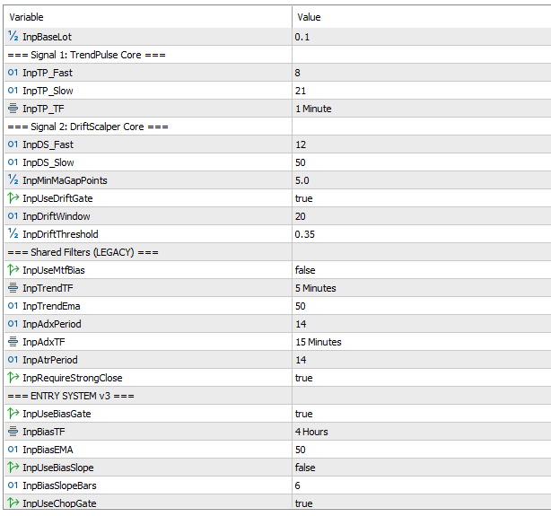
The risk & compounding group — the 5% aggressive setting lives here.
Input | What it does
InpRiskPerR_Pct | The big one. Risk per R as a percent of the account. Default is a conservative 1.0%. This is the input you raise for the aggressive “Preset B” profile — e.g. 5.0% for 5× compounding. Higher = larger positions = deeper drawdowns. Handle with care.
InpCompoundMode | High-impact. How position size scales with the account. Mode 2 (HWM %peak) sizes off the balance high-water mark — the verified default. This is what makes compounding work.
InpRMultiple | The R unit: 2.0 × ATR(M15). Defines the distance of one “R” of risk. Rarely changed — it’s core to how every other level (rungs, breaker) is measured.

The 5% compounding setup
To run the aggressive Preset B: set InpRiskPerR_Pct = 5.0 with InpCompoundMode on the HWM %peak mode. Expect the returns and the drawdowns to scale together — Preset B reached +307% but with 27% drawdown in testing. This is for high risk tolerance only, on money you can genuinely afford to lose.

4 · Entry logic & the fuel gate
GoldenGoose is a single PULLBACK engine. It enters on a pullback to the M15 EMA20 that reclaims in the trend direction (Trigger B), plus a structural breakout path (Trigger C), gated by the higher-timeframe bias and a chop filter. The fuel gate is the volatility filter that keeps it out of dead markets.
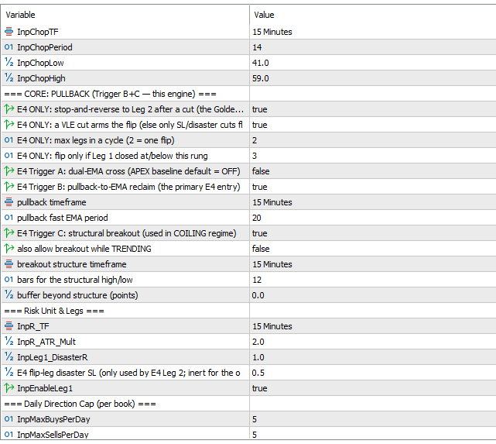
The entry / fuel-gate group. In GoldenGoose these thresholds are shown openly.
Input | What it does
InpFuelGateOn | High-impact. The master switch for the fuel gate. ON (default) applies the volatility filter. Turn it OFF to reproduce the original ungated run for comparison.
Fuel thresholds | A signal becomes a trade only when vol_ratio ≥ 1.171 AND ADX < 29.3 — fitted on E4’s own trade record and shipped frozen. This is the filter that skips low-opportunity chop.
H4 EMA50 bias | Trades only align with the higher-timeframe direction — a trend filter, not usually changed.
M15 chop gate | Skips the 41–59 dead-zone of the chop index, so the engine sits out directionless markets.

Why “frozen”? The free GoldenGoose ships the fuel gate exactly as it was measured and does not re-tune it as regimes shift. That’s the deliberate limitation of the free tier — the maintained, continuously re-tuned version is what APEX Pro provides. It’s stated plainly so nothing feels hidden.

5 · Exits — ladder, trail, flip & breaker
GoldenGoose banks profit in stages and manages risk with a hard stop, an adaptive trail, a stop-and-reverse flip, and a daily breaker. These are the mechanics behind the numbers.
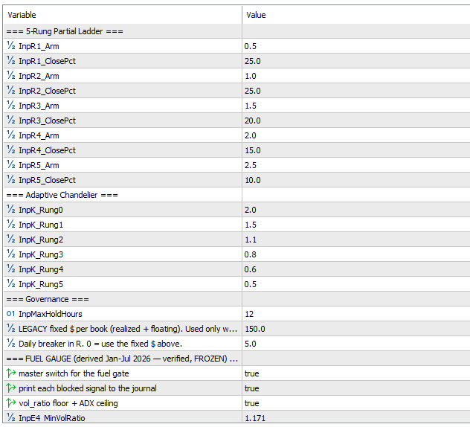
The exit-management group.
Input / mechanic | What it does
Disaster stop | L1 = 1.0R hard stop, shipped with every order from the first tick. After a cut, one flip to L2 at 0.5R (max 2 legs).
5-rung ladder | Banks partial profit at 0.5 / 1.0 / 1.5 / 2.0 / 2.5 R, closing 25 / 25 / 20 / 15 / 10% at each rung.
k-trail | Adaptive chandelier trail that tightens by rung: 2.0 → 1.5 → 1.1 → 0.8 → 0.6 → 0.5 × ATR.
Flip | E4 stop-and-reverse: flips ≤ rung 3, max 2 legs, 12h stop. This is the engine’s signature behaviour.
Breaker | R-anchored daily breaker at 5.0R (shown as $214.57 at an R of $42.91). Scales with the bet instead of tripping harder as risk rises.
Pyramiding | On — adds at rung 2, max 3 tiers, size 0.50× each. Compounds winners.

6 · The minor inputs (still worth knowing)
These won’t transform the system, but they shape its edges — and knowing them means you’re never guessing.
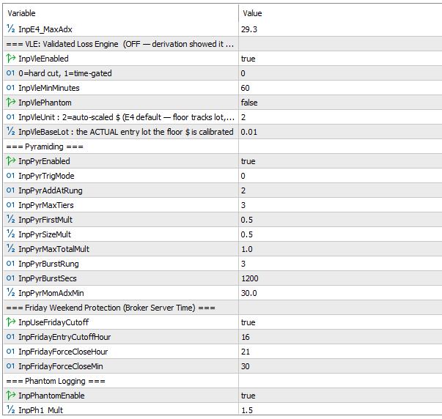
Protection & housekeeping group.
Input | What it does
Friday protection | Entry cutoff at 16:00 and force-flat at 21:30 (server time) to avoid the weekend gap. Minor, but it protects against Monday surprises.
Day cap | 5 buys / 5 sells per day, one position at a time (the L2 flip leg is free). Caps overtrading.
VLE (Validated Loss Engine) | Present in the code but OFF by default — testing showed the floor cost money on this gated population. Left in, off, and documented honestly.
Telegram inputs | Bot token / chat ID for the live trade feed. Optional — purely for notifications.

7 · Setting up the AI Sidecar (GateKeeper)
The AI layer runs as a small Python program — the sidecar — on the same machine as MetaTrader. The EA talks to it over http://127.0.0.1:8765/. Below is the full setup for both Windows and Mac. Do the prerequisite first.
Prerequisite — do this before anything else
Create a folder for the sidecar (for example a GateKeeper-SideCar folder on your Desktop) and put the sidecar files in it (apex_gatekeeper.py, ping_test.py, feed_test.py). Then open your command line — CMD on Windows, Terminal on Mac — and install the requirements into that environment:
pip install MetaTrader5 feedparser requests
Get your OpenAI API key first from https://platform.openai.com/settings/organization/api-keys (or, to run fully offline and free, install Ollama and pull llama3 instead).

Windows
- CD into the folder:
cd C:\Users\Administrator\Desktop\GateKeeper-SideCar
- Set the API key:
setx OPENAI_API_KEY sk-your-key-here
- Start the sidecar:
py apex_gatekeeper.py
- Check the key is set correctly:
echo %OPENAI_API_KEY%
- Ping to test the AI agents are live (open a separate CMD window and CD into the folder first):
py ping_test.py
- Test the news feed:
py feed_test.py

Mac
- CD into the folder:
cd ~/Desktop/GateKeeper-SideCar
- Set the API key:
export OPENAI_API_KEY=sk-your-key-here
- Start the sidecar:
python3 apex_gatekeeper.py
- Check the key is set correctly:
echo $OPENAI_API_KEY
- Ping to test the AI agents are live (open a separate Terminal window and CD into the folder first):
python3 ping_test.py
- Test the news feed:
python3 feed_test.py
Mac note
On Mac the export command sets the key for the current Terminal session. If you close the window you’ll need to run it again, or add it to your shell profile (~/.zshrc) to make it permanent. Otherwise the steps are identical to Windows — just python3 instead of py, and $OPENAI_API_KEY instead of %OPENAI_API_KEY%.

What “all okay” looks like
When the sidecar is running and the tests pass, the console shows the agents live and the news feed responding. This is the healthy state — leave the sidecar window running while you trade:
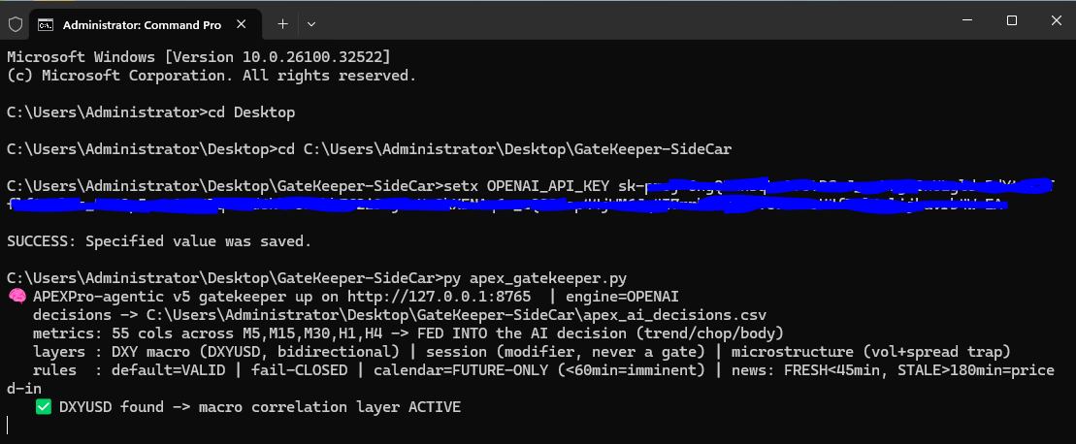
The AI GateKeeper sidecar running — agents live, all checks green.
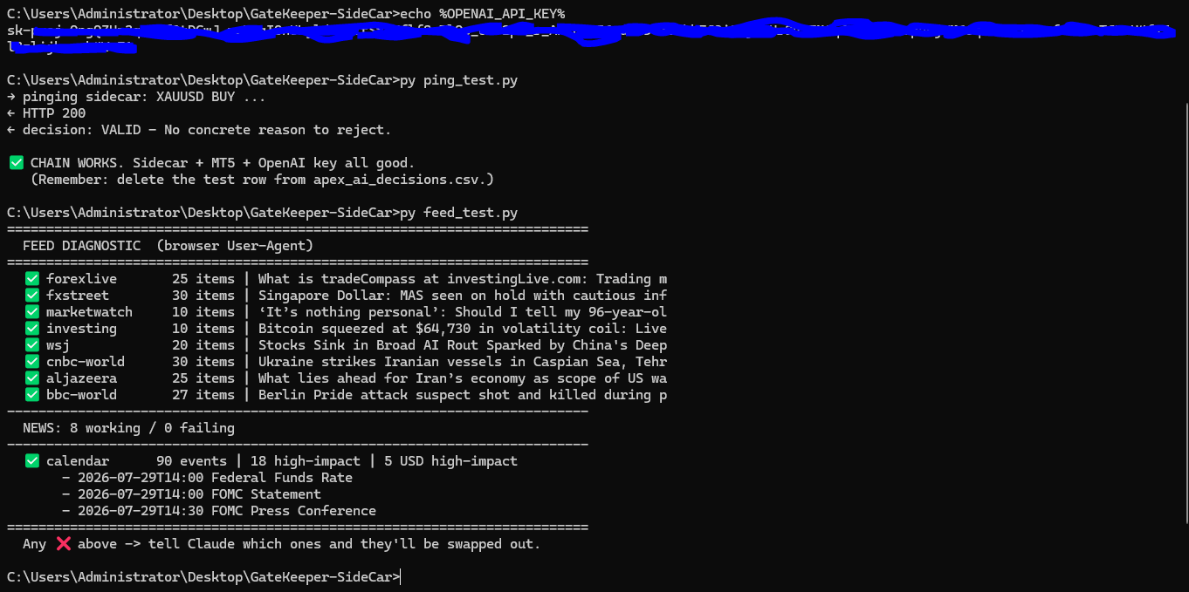
The ping and feed tests returning healthy responses.

Wiring the EA to the sidecar
- In MetaTrader: Tools → Options → Expert Advisors → Allow WebRequest for listed URL, and add http://127.0.0.1:8765.
- In the EA inputs, set InpUseAIGate = true.
- Confirm the boot banner now shows AI gate ON — fail-CLOSED. You’re live.

8 · Reading the live trade feed
Once running, GoldenGoose narrates its full trade lifecycle to the Experts tab and Telegram — new cycles, rung banking, pyramiding, the flip, and closed wins and losses. Learning to read these cards means you always know what the engine is doing and why.
Card you’ll see | What it means
NEW CYCLE | A fresh trade opened — shows symbol, entry price, stop, lot size, the R value, VLE, drift and ADX at entry.
RUNG 1 / 2 / 3 | A partial profit target was hit and banked; the k-trail tightens a notch each time.
PYRAMID TIER | A winner was added to (pyramided) at a rung.
REVERSAL / FLIP | The stop-and-reverse fired — the position flipped to the Leg-2 direction.
CYCLE CLOSED · WIN | A profitable cycle closed — shows exit, P/L, the running daily total, and MFE/MAE.
CYCLE CLOSED · LOSS | A losing cycle closed — same details. Shown plainly, never hidden.

The honest feed
Losses are reported exactly like wins — same card, same detail. That’s deliberate: a feed that only shows winners is a marketing tool, not a trading record. GoldenGoose shows you everything.

What the AI gate looks like live
With the AI armed, each signal shows its verdict in the feed. A VALID verdict lets the trade through with the AI’s one-line reasoning; if the sidecar is ever unreachable, you’ll see the fail-closed skip instead — proof the safety contract is working:
🧠✅ AI VALID E4@S-PULLBACK BUY XAUUSD
{"decision": "VALID - With-trend entry, price moving in favor."}

🧠✅ AI VALID E4@m-PULLBACK BUY XAUUSDmicro
{"decision": "VALID - No concrete reason to reject."}

🧠⚠ AI UNAVAILABLE BUY XAUUSD -> trade SKIPPED (fail-closed)
🧠⚠ AI UNAVAILABLE BUY XAUUSDmicro -> trade SKIPPED (fail-closed)
Live AI verdicts in the feed — a VALID pass with reasoning, and the fail-closed skip when the sidecar is unreachable.

Links
Part 1 — setup & run: https://drive.google.com/drive/folders/1hs271IgDDpWyc_rVt1Ud6rA2V0ttW2GL
Home / landing page: https://trendpulselabs.github.io/
Premium — APEX Pro v6: https://trendpulselabs.github.io/apex/
Full backtest reports: https://drive.google.com/drive/folders/1g8kcJO-PKm7I-Pa6MYpyC3xMUGzcVQDb
Telegram: https://t.me/+ZJK0gS8BuREyN2Jk
Discord: https://discord.gg/8sKk7mD4b8
Send your CSV / feedback: https://docs.google.com/forms/d/e/1FAIpQLSdwKy7vUJCXWftAQZivyANXBWFeVtkoeUbS2Rur_Fj6tkW_KA/viewform

Research and educational purposes only — not financial advice. Verify everything yourself before risking real money.

